JAX-RS - @PUT 範例

POST 和 PUT 的區別是：POST 新增資源時不會定義新的資源路徑也就說將部分路徑當作資料新增來源。而 PUT 通過定義完整的資源路徑來新增資源。
本文是針對資源 URI 提交的PUT的，就像www.example.com/api/items/10將 id 為 10 的項目建立新增資源一樣。

JAX-RS 服務方法應該用@PUT 註釋
@Path("/{sku}")
@PUT
@Consumes(MediaType.APPLICATION_JSON)
public Response createItem(Item item, @PathParam("sku") String sku) {
…
}
專案程式結構
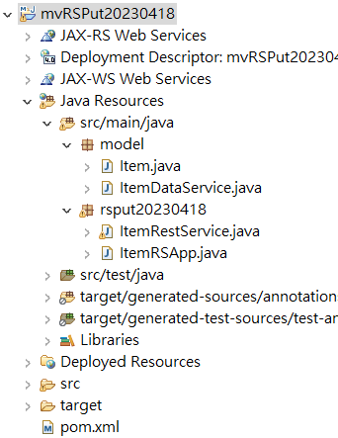
Maven pom.xml
<dependency>
<groupId>org.glassfish.jersey.bundles</groupId>
<artifactId>jaxrs-ri</artifactId>
<version>2.35</version>
</dependency>

<dependency>
<groupId>javax.xml.bind</groupId>
<artifactId>jaxb-api</artifactId>
<version>2.3.0</version>
</dependency>
<dependency>
<groupId>com.sun.xml.bind</groupId>
<artifactId>jaxb-core</artifactId>
<version>2.3.0</version>
</dependency>
<dependency>
<groupId>com.sun.xml.bind</groupId>
<artifactId>jaxb-impl</artifactId>
<version>2.3.0</version>
</dependency>

Model:

import java.math.BigDecimal;

public class Item {
private String sku;
private String name;
private BigDecimal price;

public Item() {
}

public Item(String sku, String name, BigDecimal price) {
this.sku = sku;
this.name = name;
this.price = price;
}

public Item(String sku) {
this.sku = sku;
}

public String getSku() {
return sku;
}

public String getName() {
return name;
}

public void setName(String name) {
this.name = name;
}

public BigDecimal getPrice() {
return price;
}

public void setPrice(BigDecimal price) {
this.price = price;
}

@Override
public boolean equals(Object o) {
if (this == o) return true;
if (o == null || getClass() != o.getClass()) return false;

Item item = (Item) o;

return sku.equals(item.sku);

}

@Override
public int hashCode() {
return sku.hashCode();
}

@Override
public String toString() {
return "Item{" +
"sku='" + sku + '\'' +
", name='" + name + '\'' +
", price=" + price +
'}';
}
}

DAO ItemDataService:

import java.math.BigDecimal;
import java.util.ArrayList;
import java.util.List;

public class ItemDataService {
private List<Item> itemList = new ArrayList<>();

private static ItemDataService ourInstance = new ItemDataService();

public static ItemDataService getInstance() {

return ourInstance;
}

public void createItem(String sku,String n,BigDecimal p) {
Item itemToStore = new Item(sku);
itemToStore.setPrice(p);
itemToStore.setName(n);
itemList.add(itemToStore);
}

public boolean itemExists(String sku) {
for (Item item : itemList) {
if (item.getSku().equals(sku)) {
return true;
}
}
return false;
}

public List<Item> getItemList() {
return itemList;
}

public Item getItemBySku(String sku) {
for (Item item : itemList) {
if (item.getSku().equals(sku)) {
return item;
}
}

return null;
}
}

Rest Service:

import javax.ws.rs.ApplicationPath;
import javax.ws.rs.core.Application;

@ApplicationPath("/api")
public class ItemRSApp extends Application {
}

import javax.ws.rs.*;
import javax.ws.rs.core.MediaType;
import javax.ws.rs.core.Response;

import java.math.BigDecimal;
import java.net.URI;
import java.util.List;
import model.*;

@Path("/items")
public class ItemRestService {

private ItemDataService dataService = ItemDataService.getInstance();
public ItemRestService() {
}
@GET
@Produces(MediaType.APPLICATION_JSON)
public List<Item> getItems() {
return dataService.getItemList();
}

@Path("/{sku}/{name}/{price}")
@PUT
public Response createItem(@PathParam("sku") String sku , @PathParam("name") String name ,@PathParam("price") int price) {
if (dataService.itemExists(sku)) {
//status code 204
return Response.noContent()
.build();
} else {
dataService.createItem(sku,name,new BigDecimal(price));
//status code 201
//sends back new URI in header key = 'LOCATION'
return Response.created(URI.create("/api/items/"+sku)).build();
}
}

@GET
@Path("/{sku}")
@Produces(MediaType.APPLICATION_JSON)
public Response getCustomer(@PathParam("sku") String sku) {
Item item = dataService.getItemBySku(sku);
if (item == null) {
return Response.status(Response.Status.NOT_FOUND)
.build();
} else {
return Response.ok()
.entity(item)
.build();
}
}
}

以POSTMAN測試:
新增成功
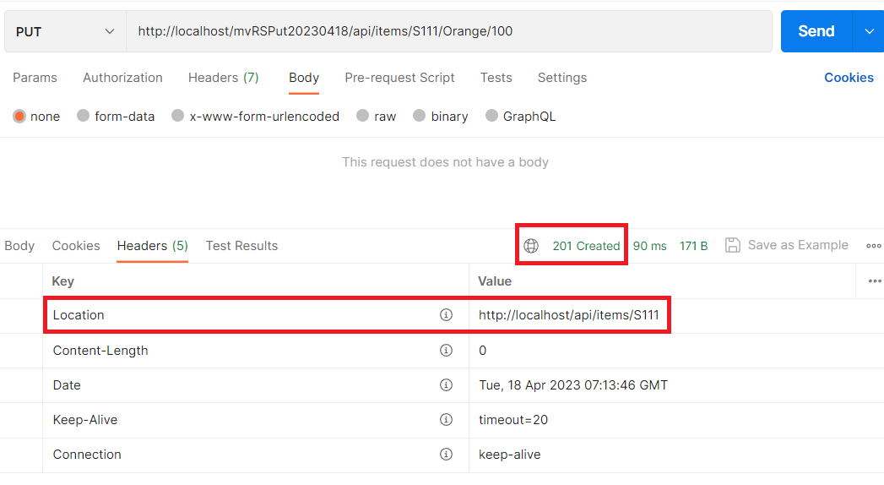

資料重複
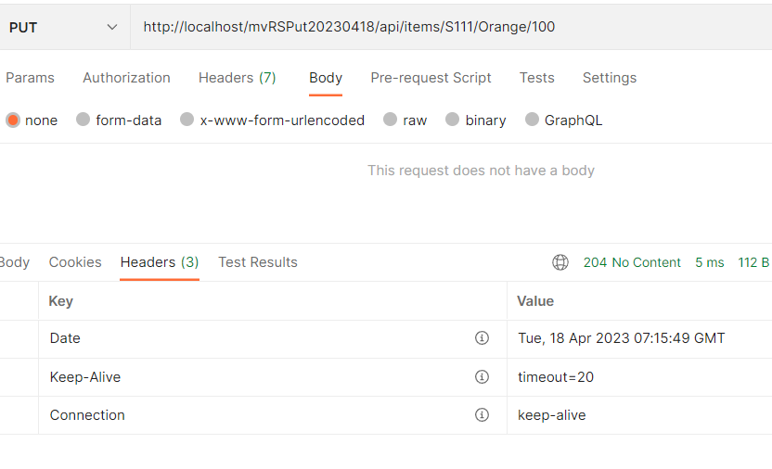

使用jQuery
<!DOCTYPE html>
<html>
<head>
<meta charset="utf-8">
<script src="https://ajax.googleapis.com/ajax/libs/jquery/3.6.0/jquery.min.js">
</script>
</head>
<body>

<h2>Create New Item Resource</h2>
<form id="item-form">
<h2>
Item Sku <input id="input-sku" type="text" name="sku"/><br/>
Item Name <input type="text" name="name"/><br/>
Price <input type="text" name="price"/><br/>
<input type="submit" value="Submit"/>
</h2>
</form>
<div id="msg"></div>

<script>
$("#item-form").submit(function(event){
event.preventDefault();
var $form = $(this);
var sku = $form.find('input[name="sku"]').val();
var url = 'api/items/'+sku;

var itemName = $form.find('input[name="name"]').val();
var itemPrice = $form.find('input[name="price"]').val();

url=url+"/"+itemName+"/"+itemPrice;

$.ajax({
type : 'PUT',
url : url,
success : function(data, status, xhr){
$('#msg').html('status: '+status+'<br/>Header Location value: '+
xhr.getResponseHeader('Location'));
},
error: function(xhr, status, error){
$('#msg').html('<span style=\'color:red;\'>'+error+'</span>')
}
});
});
</script>
</body>
</html>

